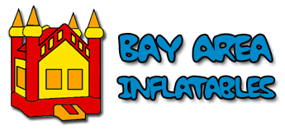

Bay Area Inflatables LLC.

Policies and Rules

Cancellation/Inclement Weather Policy

We require a $100 deposit at the time of booking your rental. If you cancel within seven days of your delivery date, we will credit your deposit towards a future rental (dependent upon availability). If you cancel more than seven days prior to delivery, we will refund your full deposit.

For the protection of your guests and our equipment, inflatables will not be used in the rain or when
the wind exceeds 15 miles per hour. If the weather is inclement on the day of your delivery, we will
contact you on the status of your delivery. If rain or wind forces us to cancel your delivery, we will
refund your full deposit if we cannot accommodate your postponement date.

Safety Policy

- Inflatable must be used under adult supervision at all times.
- Participants using the inflatables should be grouped according to size and age. Small children should not be in the inflatable with larger children and/or adults who are not supervising them.
- Participants must remove shoes, glasses, jewelry, hair bands and other materials which may damage the inflatables.
- No food, drinks, gum, or silly string are allowed in the inflatables.
- Absolutely no tumbling, flips, wrestling, or any other form of "rough housing".
- No jumping on any of the slides.
- Keep away from the sides and netting of the inflatables.
- No climbing on the exterior of the inflatables.
- Keep all hot objects (barbeques, torches, fireworks etc.) away from the inflatables.
- Keep away from swimming pools.
- Do not tape or fasten anything to the inflatable.

Inflatable Requirements

- Electric Outlet within 100 feet of the inflatable.
- Ground must be dry and free of debris.
- Must have a flat surface large enough to accommodate the inflatable (Bay Area Inflatables has the right to deny set up on steep hills or other unsafe locations.)
- If the wet/dry slide is used as a wet slide, a hose bib must be within 100 feet.

